**Experiment 4**

**DATE-13.10.2020**

**Aim**

To design circuits of binary to gray, gray to binary and BCD to Seven segment display

**Apparatus required**

1) Tinkercad Software for designing circuits

2) Breadboard

3) Power Supply

4) Slideswitch

5) IC of Logic gate(74HC86)

6) Resistors(331 ohm)

7) Led bulb for signal

8) DIP SPST X4 switch

9) Seven segment decoder(CD4511)

10) Seven Segment display

**Theory**

GRAY CODE

**Gray code** – also known as **Cyclic Code**, **Reflected Binary Code** (RBC) or **Grey code** – is defined as an ordering of the binary number system such that each incremental value can only differ by one bit. In gray code, while traversing from one step to another step only one bit in the code group changes. That is to say that two adjacent code numbers differ from each other by only one bit.

Gray code is the most popular of the unit distance codes, but it is not suitable for arithmetic operations. Gray code has some applications in analog to digital converters, as well as being used for error correction in digital communication.

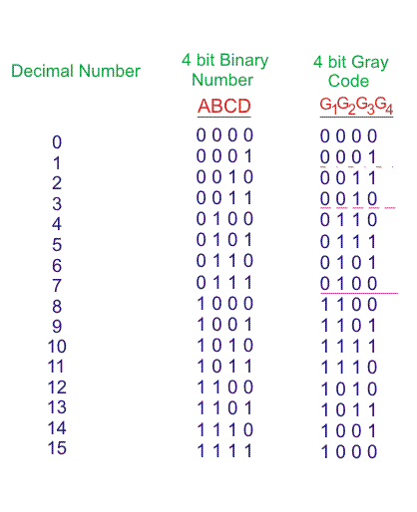

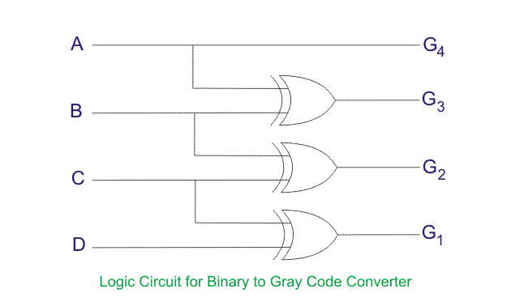

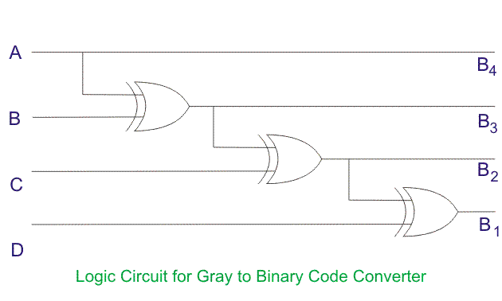

SEVEN SEGMENT DISPLAY

The 7*-*segmentdisplay, also written as “seven segment display”, consists of seven LEDs (hence its name) arranged in a rectangular fashion as shown. Each of the seven LEDs is called a segment because when illuminated the segment forms part of a numerical digit (both Decimal and Hex) to be displayed. An additional 8th LED is sometimes used within the same package thus allowing the indication of a decimal point, (DP) when two or more 7-segment displays are connected together to display numbers greater than ten.

Each one of the seven LEDs in the display is given a positional segment with one of its connection pins being brought straight out of the rectangular plastic package. These individually LED pins are labelled from athrough to g representing each individual LED. The other LED pins are connected together and wired to form a common pin.

So by forward biasing the appropriate pins of the LED segments in a particular order, some segments will be light and others will be dark allowing the desired character pattern of the number to be generated on the display. This then allows us to display each of the ten decimal digits 0 through to 9 on the same 7-segment display.

The displays common pin is generally used to identify which type of 7-segment display it is. As each LED has two connecting pins, one called the “Anode” and the other called the “Cathode”, there are therefore two types of LED 7-segment display called: **Common Cathode**(CC) and **Common Anode** (CA).

The difference between the two displays, as their name suggests, is that the common cathode has all the cathodes of the 7-segments connected directly together and the common anode has all the anodes of the 7-segments connected together and is illuminated as follows.

1. The Common Cathode (CC)–In the common cathode display, all the cathode connections of the LED segments are joined together to logic “0” or ground. The individual segments are illuminated by application of a “HIGH”, or logic “1” signal via a current limiting resistor to forward bias the individual Anode terminals (a-g).

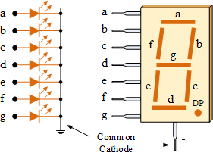

2. The Common Anode (CA)–In the common anode display, all the anode connections of the LED segments are joined together to logic “1”. The individual segments are illuminated by applying a ground, logic “0” or “LOW” signal via a suitable current limiting resistor to the Cathode of the particular segment (a-g).

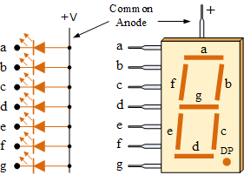

In general, common anode displays are more popular as many logic circuits can sink more current than they can source. Also note that a common cathode display is not a direct replacement in a circuit for a common anode display and vice versa, as it is the same as connecting the LEDs in reverse and hence light emission will not take place.

Depending upon the decimal digit to be displayed, the particular set of LEDs is forward biased. For instance, to display the numerical digit 0, we will need to light up six of the LED segments corresponding to a, b, c, d, e and f. Thus the various digits from 0 through 9 can be displayed using a 7-segment display as shown.

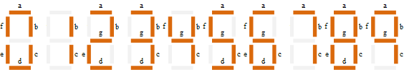

**Observation**

Binary to Gray code converter circuit

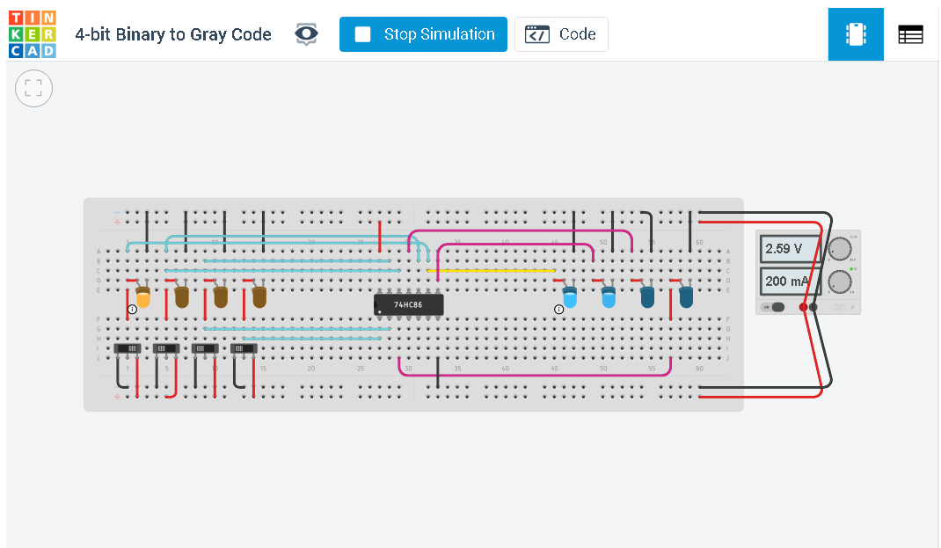

Gray to Binary code converter circuit

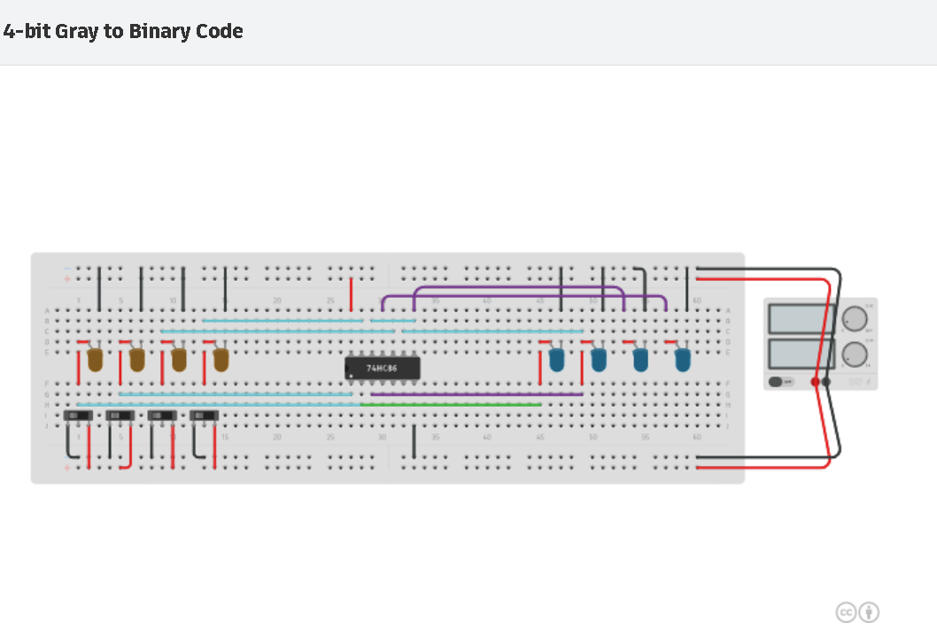Binary to Seven segment Display

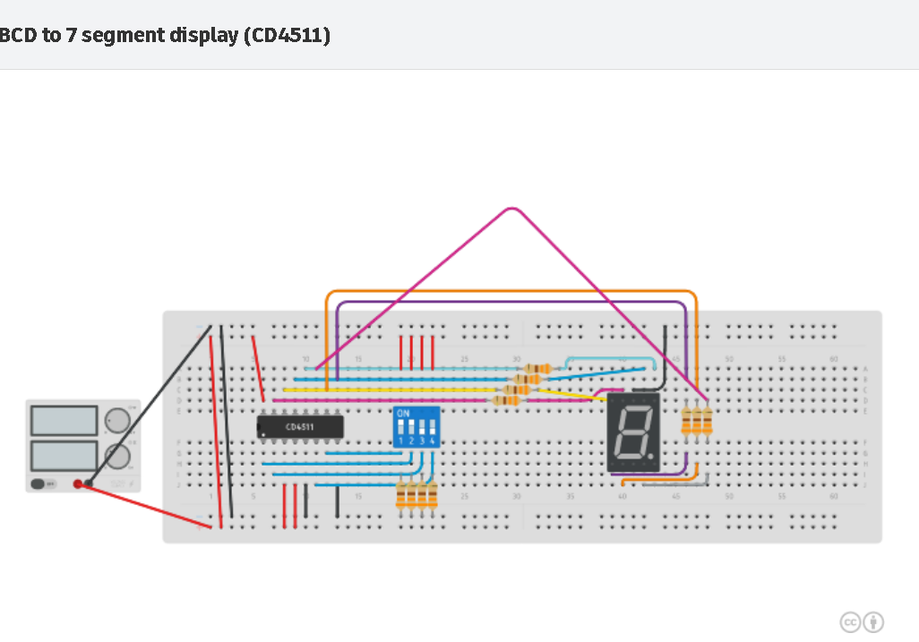

**Conclusion**

Hence, I have successfully observed and performed all the experiments given in class.

**Name: Harsh Kumar**

**Branch: CE- 3rd Sem.**

**ID- B219027**